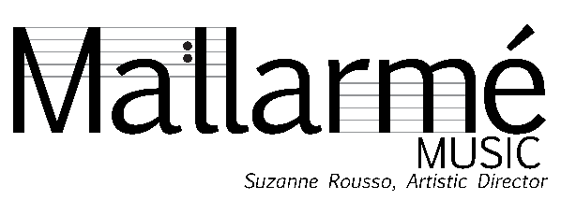
2023 NC HIP Music Festival
Biber Bowl Revisited

Saturday, February 4 I 3:00 p.m. - Christ Church, Raleigh
Sunday, February 5 I 3:00 p.m. - St. Paul’s Lutheran Church, Durham
Martha Perry & David Wilson – violin
Joey O’Donnell & Suzanne Rousso – viola |Stephanie Vial – cello
Jennifer Streeter – harpsichord | Daniel Swenberg – theorbo
Kathryn Adduci – trumpet | David Faircloth – baritone
Music of Heinrich Ignaz Franz Biber (1664-1704)

Sonata IV à cinque from Sonatae Tam Aris Quam Aulis Servientes
[Allegro] - Allegro – Adagio – Presto – Allegro

Sonata III in F Major (1681), C. 140
Adagio – Presto
Aria
Presto – Adagio
Variatio
Mystery (Rosary) Sonata No. 2 “The Visitation”
Sonata – Presto – Allamande - Presto

Harmonia Artificiosa in A Major, Partia III
Praeludium
Allamande
Amener
Balletto
Gigue
Ciacona

---INTERMISSION –

Mensa Sonora in A Minor, Pars III, C.71
Gagliarda
Sarabanda
Aria
Ciacona

Serenada à cinque for strings, baritone & cembalo “Nachtwächter” A. 877a
Serenada
Allamanda
Aria
Ciacona
Gavotte
Retirada

Sonata à 6 in C Major (c. 1673)
Allegro – Presto – Adagio – [Allegro]

BECOME A HIPSTER TODAY!
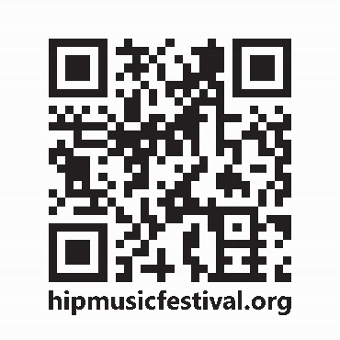
Mallarmé subscribers or single ticket buyers may apply the cost of your purchase to a HIPster pass TODAY!
Do not miss any of the 18 event 2023 NC HIP Music Festival. See us at the front table to upgrade and go to hipmusicfestival.org for the full
HIP festival lineup!

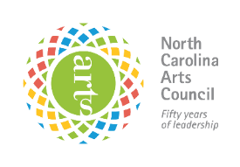

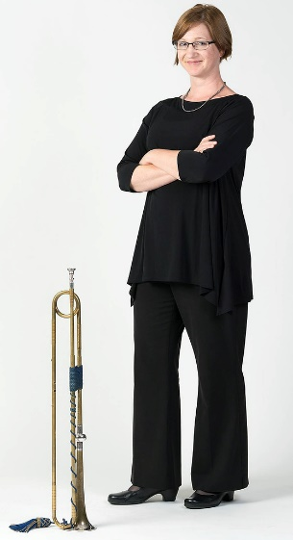
Today’s Artists
Kathryn Adduci, trumpet, has performed and taught throughout the world. She has appeared with numerous professional orchestras in her native Australia including as a soloist with the Adelaide Symphony Orchestra and the West Australian Symphony Orchestra, and has also performed with orchestras in Malaysia, Canada, and the United States. ​

A versatile performer, Adduci is highly regarded for her work with historical instruments. She has been described as “a rare treat”…”a highly skilled trumpeter” (Denver Post), her playing described as “flawless, elegant”…”delicate as that of a flute, yet with all the power and color of brass” (SanDiego.com). She has performed with numerous period instrument groups in North America, including the Philharmonia Baroque Orchestra, American Bach Soloists (San Francisco), Tafelmusik Baroque Orchestra (Toronto), Apollo’s Fire (Cleveland), Bach Collegium San Diego, Portland Baroque Orchestra (Oregon), Musica Angelica (Los Angeles), as well as for the Carmel Bach Festival.
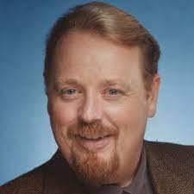
David Faircloth, baritone, is known for his vocal versatility, has been featured in musical ensembles ranging from the Washington Bach Consort to the New York City Opera National Company. The Washington Post has noted his “…rich, rangy, and intense singing,” as well as his “…colorful and richly comic portrayals.” He has also appeared with The Washington National Opera, Baltimore Opera, OperaDelaware, The Cathedral Choral Society, The Mantovani Orchestra, American Vocal Ensemble, and spent three seasons in the chorus of the Metropolitan Opera. He is currently the Program Coordinator for Chapel Music at Duke University Chapel and also serves Duke Chapel as a staff singer for its choral ensembles and for the Chapel’s Bach Cantata series.

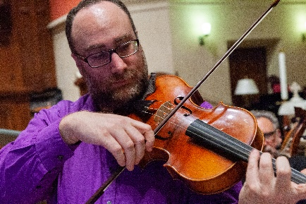
Joey O’Donnell, baroque violin and viola, lives in central North Carolina where he has been performing and teaching for the last eight years. In recent history he has performed with Seraphic Fire, the nationally-acclaimed chamber choir (early music through contemporary) based in Miami; and with the English Country Dance band Collard Greene, Wild Rose, and various Broadway touring shows. He performs with regional early music ensembles, maintains a studio of thirty students, and leads the Meredith College Fiddlers, a reading group for youngsters.

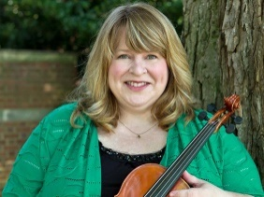
Martha Perry, baroque violin lives in Bloomington, Indiana. Her playing has been called “ideally realized…taut and loaded with nuance” by the Atlanta Journal-Constitution. Ms. Perry performs with many U.S. period instrument ensembles including the Indianapolis Baroque Orchestra and Atlanta Baroque Orchestra, the Washington Bach Consort, Opera Lafayette of Washington, D. C., the Dallas Bach Society, and Foundling Baroque Orchestra. Having appeared in productions with the National Cathedral Baroque Orchestra, at Wolftrap, for the Magnolia Baroque Festival, St. Louis, and Bloomington Early Music Festival, the Victoria Bach Festival, and in Italy’s 2003 Musica nel Chiostro, Martha also performs regularly with Bourbon Baroque, Quince, Ensemble Voltaire, The Comic Intermezzo, Musika Ekklesia, and on Chicago’s Ars Antigua Presents early music series. Martha has been heard in a live international broadcast on Chicago’s WFMT radio, on the early music program Harmonia, and on National Public Radio’s “Performance Today,” and has recorded for Edition Lilac, Musica Omnia, Naxos, WFIU, the National Cathedral, and Concordia Records. Ms. Perry completed her Master of Music in Early Music Performance at Indiana University, where she was a student of Stanley Ritchie, and served as Ritchie’s graduate assistant for the Baroque orchestra. Martha has served as the Interim Executive Director for the 2005 Bloomington Early Music Festival.

Suzanne Rousso’s bio can be found on page 10 of the Playbill

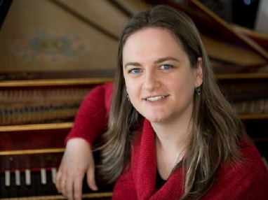
Jennifer Streeter, harpsichord, has performed throughout the United States and Europe with ensembles such as the North Carolina, Indianapolis and Seattle Baroque Orchestras, Piedmont Baroque, Ensemble 415, and the Monte Carlo Philharmonic Orchestra. She has been featured at the Bloomington, Magnolia Baroque and Amherst Early Music Festivals. She holds masters’ degrees in recorder and harpsichord from the Early Music Institute at Indiana University, studying with Eva Legêne and Elisabeth Wright. Originally from Europe, she now calls Cary, North Carolina home where she is a freelance musician and body therapist.

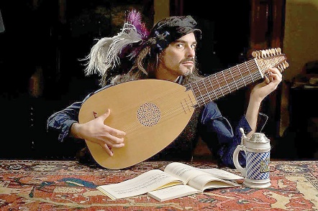
Daniel Swenberg, theorbo, plays a wide variety of lutes and guitars: baroque, renaissance, classical/romantic – small, medium, and large. Chief among these is the theorbo – the long lute that you are either wondering about or overhearing your neighbor discuss.

While based in New York, Daniel schleps instruments throughout North America and Europe to play with a wide range of ensembles: ARTEK, REBEL, The Metropolitan Opera, Mr. Jones & the Engines of Destruction, Ensemble Viscera, New York City Opera, Opera Atelier/Tafelmusik, The New York Philharmonic, the Philadelphia Orchestra, Catacoustic Ensemble, the Four Nations Ensemble, Apollo’s Fire, Handel & Hayden, The Green Mountain Project, Tenet, Skid Rococo, the Newberry Consort, with soprano Nell Snaidas, Lizzy & the Theorboys, Music of the Baroque, the Aspen Music festival opera, Staatstheatre Stuttgart, the Orchestra of St Lukes, and more. He accompanied Renee Fleming and Kathleen Battle at Carnegie Hall and is on faculty at Juilliard’s Historical Performance program.

Prior to this life’s incarnation as a Lutenist, he studied classical guitar at the North Carolina School of the Arts, and musicology at Washington University (St. Louis). His programing integrates and emphasizes music with the history, sciences, economics, politics, and broader culture of its time.

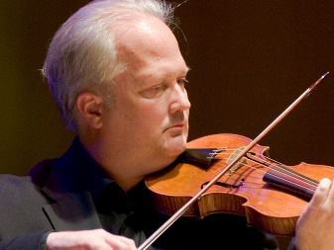
David Wilson, baroque violin, has performed extensively with period instrument ensembles in the United States and Europe, including Philharmonia Baroque Orchestra, Portland Baroque Orchestra, and Los Angeles Baroque Orchestra, and as concertmaster with Jubilate Baroque Orchestra, the California Bach Society, Apollo Baroque Orchestra, the Dayton Bach Society, and Ensemble Musical Offering.

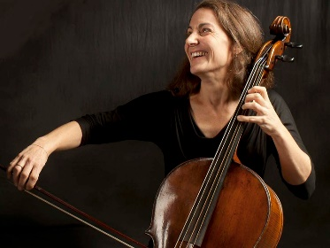
An avid chamber musician, he performs with Magnificat, the Albany Consort, Ensemble Vermillian, and Lux Musica, and he is a founding member of Florilegia, Ensemble Seicento, Aurora Baroque, and the Galax Quartet. A co-founder of the Bloomington Early Music Festival, he performs regularly at the Boston Early Music Festival, the Berkeley Early Music Festival, and the San Luis Obispo Mozart Festival. He has taught Baroque violin at Indiana University, where he earned the Doctor of Music degree in Early Music, and he holds degrees in violin from Bowling Green State University in Ohio and The Catholic University of America in Washington, D.C. He is the author of Georg Muffat on Performance Practice, published by Indiana University Press.
Stephanie Vial, baroque cello is a widely respected cellist, praised for her technical flair and expressive sense of phrasing. Vial performs regularly in early music ensembles throughout the US and has given solo and chamber music concerts, lectures, and master classes at numerous universities and institutions: including The Shrine to Music Museum in Vermillion, South Dakota, The University of Virginia, Duke University, and The Curtis Institute of Music. She is co-director of the period instrument ensemble The Vivaldi Project and its educational arm, the Institute for Early Music on Modern Instruments (EMMI).

Vial received her undergraduate degree from Northwestern University, an MM from Indiana University, and a DMA in 18th-­century performance practice from Cornell University. Her book, The Art of Musical Phrasing in the Eighteenth Century: Punctuating the Classical “Period,” published by the University of Rochester Press, was praised by Malcolm Bilson as “inspired scholarship” and “essential reading.” She has recorded for the Dorian Label, Naxos, Hungaroton, and Centaur Records, with a recent release of string trios for MSR Classics, titled Discovering the Classical String Trio. Vial lives in Durham, N.C.
PROGRAM NOTES
Heinrich Ignaz Franz Biber 1644-1704
A Bohemian by birth, Heinrich Ignaz Franz von Biber was composer and virtuoso violin player, who developed many novel techniques of violin playing, including scordatura (literally discord) tuning, in which the strings are tuned to unconventional pitches. The technique was popular in the early Baroque, either for special effects or to make some passages easier to play. Biber also used col legno playing, in which the strings are hit with the wood of the bow. He had a great gift for melody and a thorough understanding of counterpoint.
Little is known of Biber's childhood and training. He started his career as the employee of the bishop of Olomouc in Moravia, gaining a stellar reputation for his violin playing and compositions. But life in the provinces was not for him, and after two years he left his employment illegally (at the time you had to have your employer's release before leaving your job), and settled in Salzburg, one of the major musical centers of the Hapsburg empire. He spent there the rest of his life flourishing as employee of the Archbishop, rising at age 35 to become Kapellmeister at the Cathedral and subsequently dean of the choir school. In 1690, Emperor Leopold I raised him to nobility with the title Biber von Bibern. He fathered 11 children, four of whom survived: two sons who became violinists at the Salzburg court and two daughters who became nuns.
Biber was a prolific composer and many of his works are sonatas for violin and continuo. With their inventiveness and technical difficulty, they represent the pinnacle of seventeenth-century violin playing and composition. It is said that he raised the fiddle (his own designation) to violin status. He also composed at least two operas and numerous choral works, including the Missa Salisburgensis for the huge Salzburg Cathedral, a polyphonic mass setting for 53 voices in seven divided ensembles positioned throughout the cathedral for stereophonic effect.
Biber's music was forgotten after his death, although there is evidence that Mozart rummaged through his manuscripts in the Salzburg Cathedral's library. Austrian musicologists rediscovered the Rosary Sonatas around the turn of the 20th century, initiating a resurgence of interest in his music.
Sonata IV a cinque from Sonatae Tam Aris Quam Aulis Servientes (Sonatas as much for the altar as for the table) for trumpet, violin, 2 violas, violone and basso continuo, is from a group of 12 virtuoso sonatas for various combinations of strings and trumpet, ending with a fanfare number for trumpet duet. Biber does not use scordatura in this set. It was published in Salzburg in 1676 and dedicated to the Archbishop.
Sonata III in F Major is one of eight sonatas for violin and continuo, first published in 1681. It is a work that showcases the violin, with sparce accompaniment from the continuo that gives much flexibility for the violinist to be creative with tempo and dynamic contrast.
Rosary Sonata No. 2 “Visitation” (Mary's visit to Elizabeth, her cousin – Luke 1:39-45). The fifteen Rosary Sonatas for violin and continuo, also known as Mystery Sonatas, were written as musical representations of the Fifteen Mysteries of the Rosary. In each sonata, the violin is tuned differently; only the first one, "Annunciation", is tuned normally. The manuscript dates from around 1678, but it was not published until 1905. Biber ended the set with a stunning Passacaglia in G minor for violin solo, a wedding of German contrapuntal writing with Italian virtuosity.
Harmonia Artificiosa in A Major Partia III. Scored for two violins tuned scordatura and continuo, it is one of seven partitas published in 1696. In some of them, a viola or viola d'amore replaces a violin. They display a whole catalog of novel violin playing techniques.
Mensa Sonora (Sonorous Table, or Tafelmusik) Pars III in A Minor. One of a set of six suites for violin, two violas, violone and continuo published in 1680 in Salzburg. Intended as background music for aristocratic dining, Tafelmusik was popular in the 17th century Hapsburg Empire, and was usually cheerful and easy to perform. But the Mensa Sonora suites were much more than that, resembling the serenades and divertimenti of Mozart, written a century later. Pars III is in five movements, No. 4 being a chaconne.
The Serenada à 5 "mit dem Nachtwächterlied" (Serenade for Five Instruments, with the Night Watchman's Song.) This is a typical multi-movement serenade, a form used by later classical composers like Mozart and Beethoven; Biber was definitely ahead of the curve.
Biber incorporated a short vocal part into the program in this work, a bass-baritone to play the “Night Watchman” in the chaconne. Midway through this movement, played by lute-like plucked strings, a vocalist materializes out of nowhere, singing the texts of what were apparently actual Salzburg night- watchman calls:
Lost Ihr Herrn Undt last euch sagn, der Hammer der Hat neyne (Zehne) gschlagn, hüets Feyer hüets wohl, Undt lobet Gott den Herrn, Undt Unser liebe Frau.

Listen, good gentleman, and let me announce, the bell has struck nine (ten); guard your fires, guard them well, and praise God the Lord and our dear lady!
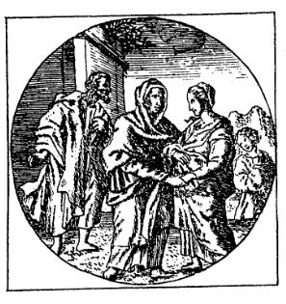
Sonata à 6 (c. 1673) for Trumpet, 2 Violins, 2 Violas and Bass is also called a Concerto. After a short ensemble ritornello, there is a slower B section that includes a soulful melody played by the first violin, with the rest of the strings chiming in later. There is a back and forth with the brighter A section which ultimately brings us back to a declamatory call of the trumpet to end the work.
Program notes by:
Joseph & Elizabeth Kahn
Wordpros@mindspring.com, www.wordprosmusic.com
(The image on left is from Biber’s score of “The Visitation”)
MANY THANKS TO MALLARMÉ’S SUPPORTERS
7/1/2022 –1/25/2022
BENEFACTOR
Anonymous
North Carolina Arts Council

SEASON CO-PRODUCER
Durham Arts Council
Mary Duke Biddle Foundation
CONCERT SPONSOR
Jeffery Beam & Stanley Finch*
Martha Hsu

CONCERT CO-SPONSOR
Anne Parks
Kathy & Lex Silbiger

PATRONS
Margareta Claesson
Dick & Judith Fox
Susan Gidwitz
Thomas Kenan
Elizabeth Matheson*
Florence Nash
Pappas Capital and AMP Charitable Fund*
Anna Ludwig and Steve Wilson

ADOPT-A-MUSICIAN
Laura Roe*
Mike & Sarah Woodard
David & Laura Frankstone*
Mark Garcea*
Sandra Izhakoff/ Rousso Sportswear
D.G. & Harriet Martin*
Walter Andrzejewski & James Maurer*
David B. Elsbree & Lorraine Gilmore
Lynn Goodpasture
Jane Holding*
Shauna Holiman & Robert Hackney*
Margaret Rich*
DONORS
Anne Berkley
Barbara Braatz
Lauren Brinkley-Rubinstein*
W Steven Burke & Randy Campbell*
Claude S. & Marjorie Y. Burton*
Tom and Denise Butts
Gail & Phil Cooley*
Stephen Costello*
Ruth & Sidney Cox
Dennis Dean*
Cheryl & John Denardo
Joseph Dirr & Laura Rapuano
Janice Dodds
Shirley Drechsel & Wayne Vaughn*
Judith Engberg
Arthur & Debbie Finn*
Barbara Freedman
Frances Gravely*
Jane Hamborsky
Anna Hayes*
Kathleen Holt and Stephen Lurie
Steve Jaffe & Mindy Oshrain
Helen Johnson*
John L. Johnston & James Rives*
Anne & Nathan Leyland
Paul Hrusovsky & David Lindquist*
Charles Lohr
Alexander Matthers
Alice & John May*
Joan Mertens
Kenneth Moore*
Mary Morrow*
Daniel & Roxanne Nagy*
Drake Maynard & Moreton Neal*
Ellen Obrien*
Ippy & Neil Patterson*
Maureen Quilligan*
Harry Rhoads Jr.*
Clyde Robinette & Romayne Smith*
Frances Rollins
Harilyn Rousso
Joyce Rutledge
Jill Shires*
Hal Crowther & Lee Smith*
Gregory & Linda Smith*
Sue Slatkoff & Ronald Strauss*
Kristine Sullivan*
Holden & Patti Thorp*
Bonnie and Fred Thron Jacobowitz
Robert Upchurch
Mary Frances Vogler*
Eric Hallman & Elizabeth Woodman*

*Donations marked with an asterisk were made in support of
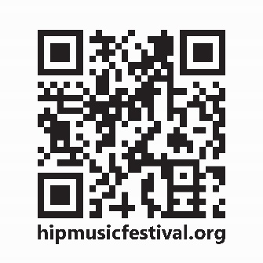
our upcoming event, The Life of a Bee, a concert honoring poet Jeffery Beam.
To learn more about the 2023 NC HIP Music Festival
go to hipmusicfestival.org

Newly added: Baroque Brunch @ Alley Twenty Six
Sunday, February 12 from 12 p.m. – 2 p.m.
Salomé Sandoval, lute and voice
Reservations: https://www.alleytwentysix.com/

